

***Driver Drowsiness Detection System***

**Name: Ajay Ashok Walke**

**MIS: 112015006**

**Year: 2nd (4th semester)**

***Guide: Dr. Tanmoy Hazra***

**ACKNOWLEDGEMENT**

This project would not have been possible without the help and cooperation of many. I would like to thank the people who helped me directly and indirectly in the completion of this project work.

First and foremost,

I would like

to express

my gratitude

to our beloved

director,

**Dr. Anupam Shukla**, for providing his kind support in various aspects.

I would like to express my gratitude  to  my project guides  and of the head of department **Dr. Tanmoy Hazra**, Assistant Professor, Department of CSE, for providing excellent guidance, encouragement, inspiration, constant and timely support throughout this B.Tech project.

I would also like to thank all the faculty members in the Dept. of CSE and my classmates for their steadfast and strong support and engagement with this project.

**Index**

|  |  |  |
| --- | --- | --- |
| **Sr.no** | **Topics** | **Pages** |
| 1 | Abstract | 4 |
| 2 | Introduction | 5 |
| 3 | Motivation | 6 |
| 4 | Literature Review | 6-8 |
| 5 | Methodology | 8-9 |
| 6 | Proposed Work | 10-13 |
| 7 | Result and Discussion | 14 |
| 8 | Implementation | 14 |
| 9 | Drawbacks | 15 |
| 10 | Conclusion | 16 |
| 11 | Future work | 16 |
| 12 | References | 17 |

* **Abstract**

When a driver is in a state of fatigue, the facial expressions, e.g., the frequency of blinking and yawning, are different from those in the normal state. In this report, various methodologies are mentioned that detect the drivers’ fatigue status, such as yawning, blinking, and duration of eye closure, using video images, without equipping their bodies with devices. The report presents a drowsiness detection model that is capable of sensing the entire range of stages of drowsiness, from weak to strong. The key assumption underlying the approach is that the sitting posture-related index can indicate weak drowsiness that drivers themselves do not notice. First, determine the sensitivity of the posture index and conventional indices for the stages of drowsiness. Then, the next designed drowsiness detection model combines several indices sensitive to weak drowsiness and too strong drowsiness, to cover all drowsiness stages. Subsequently, the model was trained and evaluated on a dataset comprised of data collected from approximately 50 drivers in simulated driving experiments in the followed research papers. The results indicated that posture information improved the accuracy of weak drowsiness detection, and the proposed model using the driver’s blink and posture information covered all stages of drowsiness (F1-score 53.6%, root mean square error 0.620). With the driver, fatigue continues to cause serious and deadly car and motorcycles accidents, and the need for automatically recognizing driver fatigue and alerting the driver is apparent. Although various approaches that explore physiological and physical factors to classify driver fatigue have been developed, the overall accuracy, recognition speed, distraction in the driving process and the cost of these systems still need to be improved. In this report, a low-cost driver fatigue level prediction framework (DFLP) for detecting driver fatigue are mentioned.

***Keywords :*** *convolutional neural network, fatigue detection, feature location, face tracking, Driver’s fatigue prediction, visual features, fatigue physiological features, electroencephalogram.*

* **Introduction**

In recent years, an increase in the demand for modern transportation necessitates faster car-parc growth. At present, the automobile is an essential mode of transportation for people. In 2017, a total of 97 million vehicles were sold globally, which was 0.3% more than that in 2016 [1]. In 2018, the global total estimation of the number of vehicles being used was more than 1 billion [2]. Although the automobile has changed people’s lifestyles and improved the convenience of conducting daily activities, it is also associated with numerous negative effects, such as traffic accidents. A report by the National Highway Traffic Safety Administration [3] showed that a total of 7,277,000 traffic accidents occurred in the India in 2016, resulting in 37,461 deaths and 3,144,000 injuries. To reduce fatal road crashes caused by fatigued drivers, a variety of systems that actively monitor driver’s physiological factors such as heart rate (HR) brain waves, and electroencephalogram (EEG) have been developed. Approaches that are based on physical factors such as driver position, electromyography (EMG), and related image data have also been put forward. Other systems that focus on operating parameters such as the strength of the pedal on the brake or accelerator have also been suggested. Although excellent advances in driver fatigue detection have been made, they tend to be intrusive, which creates an obstacle and distraction in the driving process. Also, the overall accuracy is largely dependent on the driving conditions such as time of the day (i.e., daytime or night time) and the weather (e.g., clear, cloudy, rainy). The rest of the report is organized as follows: First motivation for choosing this problem. The second is the literature review. The third part is methodologies used till now for DDD, next part explains the detailed work in the various method. After those results are mentioned with the implementation of DDD. The last part includes the drawbacks, conclusion, future work, and references to this report.

* **Motivation**

Driver drowsiness is a significant factor in the increasing number of accidents on today’s roads and has been extensively accepted [2]. This proof has been verified by many researchers that have demonstrated ties between driver drowsiness and road accidents. Although it is hard to decide the exact number of accidents due to drowsiness, it is much more likely to be underestimated. The above statement shows the significance of research to reduce the dangers of accidents anticipated by drowsiness. So far, researchers have tried to model the behavior by creating links between drowsiness and certain indications related to the vehicle and the driver [2,3]. Previous approaches to drowsiness detection primarily make pre-assumptions about the relevant behavior, focusing on blink rate, eye closure, and yawning. The automobile business also has tried to build several systems to predict driver drowsiness but there are only a few commercial products available today. The systems do not look at driver performance and overlook driver ability and characteristics. Naturally, most people would agree that different people drive differently. The system that is being developed can adapt to the changes in the driver’s behavior.

* **Literature Review**

**In Jul-Aug 2015,** Chisty et. al. [4] described **‘A Review: Driver Drowsiness Detection System’**. After this survey of different types of methods, it is found that using the camera is the best method which can be easily applied and appropriate in all conditions. This research paper explores the method of computer vision and proposed a noble method to detect driver drowsiness based on detecting eyelid closing and opening using artificial neural networks as a classification algorithm. In this paper, first of all, the video frames are acquired from the camera which could be fixed in such a way that it should not obstruct the road view of the driver. Secondly, the Lab Color Space technique is applied to each frame then thresholding is to be done in an image. After thresholding, the largest region is to be detected using Connected Analysis. The face of the driver will be found in the video in such a way that it should not affect the performance of accurate face detection in terms of varying lighting conditions.

**In May 2019,** Muhammad Ramzan et. al. [5] described **‘A Survey on State-of-the-Art Drowsiness Detection Techniques’**. Drowsiness detection methods are generally classified into three main categories. It classifies the existing models into three major categories and then reviews each model in chronological order sharing its novelty, main features, and limitations (2) discusses Hybrid approaches (3) explores, top supervised learning techniques used for drowsiness detection have been explored (4) present the pros and cons and provide a comparative study of techniques are discussed (5) elaborate the research methods in the form of frameworks for better understanding.

**In August 2019,** Wanghua Deng et. al. [6] described **‘Real-Time Driver-Drowsiness Detection System Using Facial Features’**. This research paper proposes a novel system for evaluating the driver’s level of fatigue based on face tracking and facial keypoint detection. Also, designed a new algorithm and propose the MC-KCF algorithm to track the driver’s face using CNN and MTCNN to improve the original KCF algorithm. They define the facial regions of detection based on facial key points. Moreover, introduced a new valuation method for drowsiness based on the states of the eyes and mouth. Therefore, DriCare is almost a real-time system as it has a high operation speed. From the experimental results, DriCare applies to different circumstances and can offer stable performance.

**In December 2019,** Mika Sunagawa et. al. [7] described **‘Comprehensive Drowsiness Level Detection Model Combining Multimodal Information’**. This paper proposed a drowsiness detection model designed to cover all drowsiness levels, from slight to severe. The posture information was particularly useful in conjunction with blink information because the posture index showed higher sensitivity to weak drowsiness than conventional information and was able to compensate for the shortcomings of the blink information. Since blink and posture information can be obtained even while not driving, this knowledge has the potential to contribute to drowsiness detection for occupants during automated driving in addition to manual driving.

**In August 2021,** Morshed Chowdhury et. al. [8] described **‘Drivers Fatigue Level Prediction Using Facial, and Head Behavior Information’**. This study shows using facial and head behavior images as the only input source are effective for predicting the level of fatigue. The advantage of this work is that it predicts and measures the level of fatigue instead of detecting the driver’s fatigue while using low-cost equipment for the input feed. Moreover, the input sensors are detached from the driver unlike using attached sensors that hinder the driving process and may play as an obstacle for drivers. Furthermore, since developed countries will use automotive cars, many developing countries have many trucks and other vehicles operated by humans as an example, therefore this work assists driver’s safety. The proposed framework can also be used as a baseline for an engineered device that has an input sensor, and a processing unit, alternatively a device that can be connected online to a server in the loud for online processing. this device can be in a small size to be placed on the dash of the car in Infront of the driver.

* **Methodology**

The purpose of this systematic review paper is recognition and categorization of the best possible techniques, measures, tools, and classification methods for drivers’ drowsiness detection. The systematic reviews help to recognize what is in the concerned domain. All the data gathered from research papers are categorized. Once the systematic review of empirical studies is done, all gather relevant information and identify the research gaps in the existing research studies [9] are attached to the report itself. The population of systematic review consists of research papers relevant to drowsiness detection. The websites containing information regarding road safety, dangers of driver’s fatigue, reasons for fatigue, and techniques of drowsiness detection are all searched. Keywords used to search for information relevant to drowsiness are listed in the following figure.

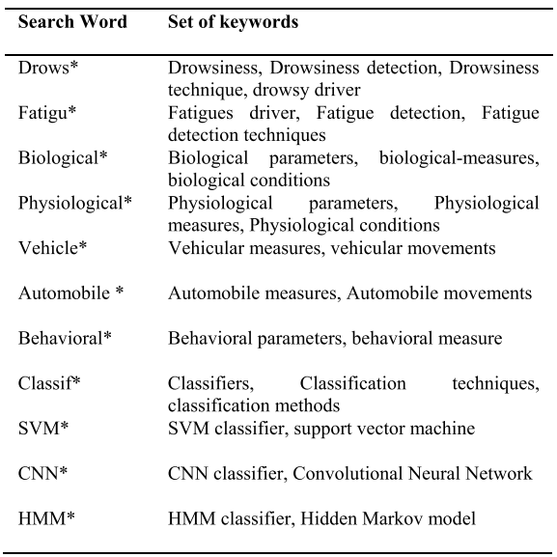

The initial search procedure produces 10 research papers; from those, we have selected 4 papers based on titles relevant to our study. Then these extracted papers are studied thoroughly, research papers are filtered out as our primary study. The complete selection process is illustrated in the Figure below. 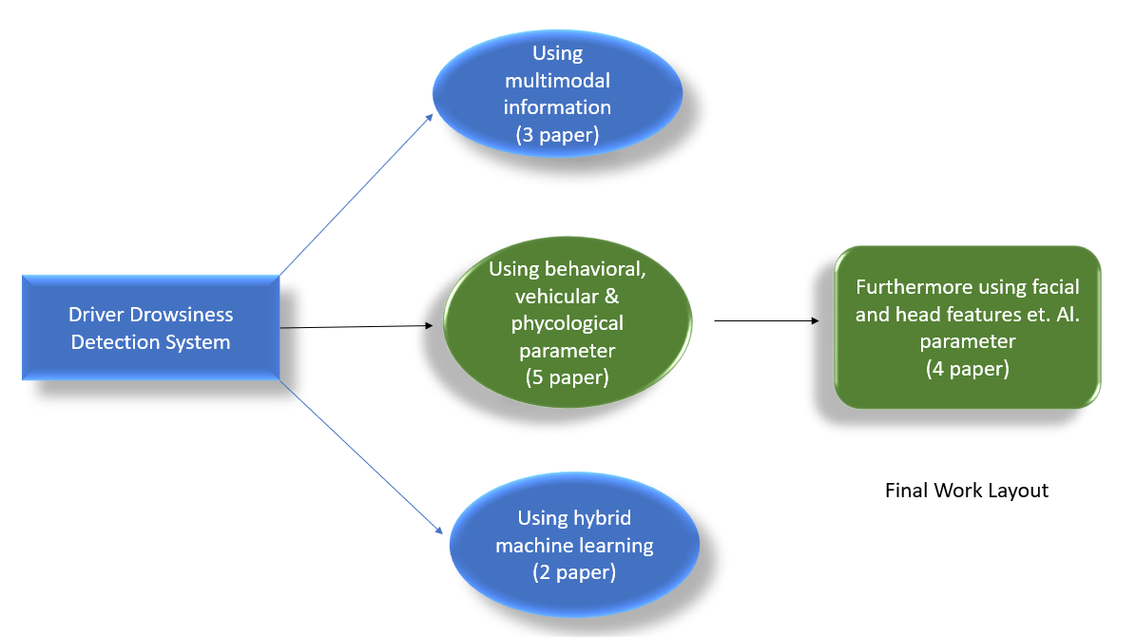

* **Proposed Work**

A detailed review of mentioned drowsiness detection techniques and their pros and cons are discussed in this section. Furthermore, the comparative analysis of such techniques is performed on different types of driving conditions The Driver Drowsiness detection system continuously monitors the drivers’ physical behavior, vehicular movement pattern, or environmental conditions based on the technique being used. Respective techniques are mentioned below and their various approaches are also mentioned in the following parts. The below techniques have been implemented till now with pros and cons.

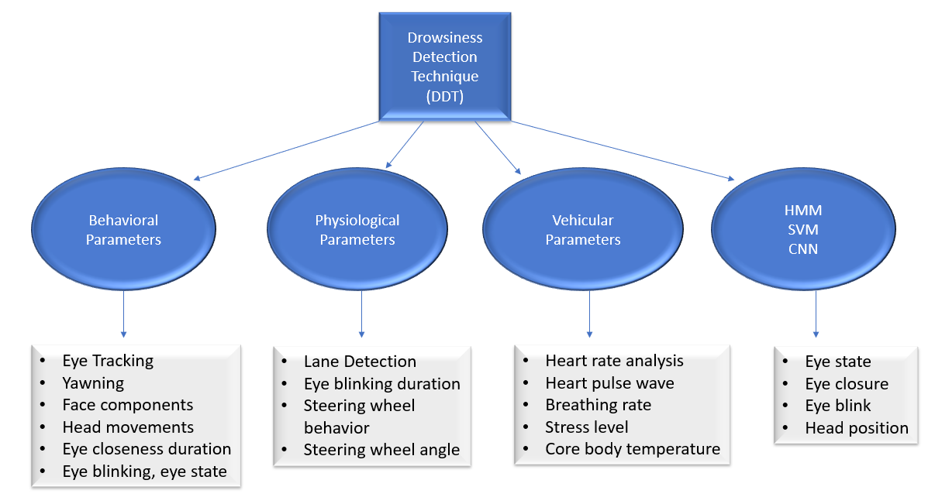

*A. Behavioural Parameter-Based DDT*

1) Eye Tracking and Dynamic Template Matching

2) Mouth And Yawning Analysis

3) Facial Expressions Method

4) Yawning Extraction Method

5) Eye Closure and Head Postures Method

6) Real Time Analysis Using Eye and Yawning

7) Eye Blink Detection Method

8) Eye Tracking System

9) Eye Blink Monitoring Method

10) Eye Closeness Detection Method

*B. Vehicular Parameter-Based Techniques*

1) Real Time Lane Detection System

2) Time Series Analysis of Steering Wheel Angular Velocity

3) Steering Wheel Angle for Real Driving Conditions For DDT

4) Automatic Detection of Driver Fatigue

*C. Physiological Parameter-Based Techniques*

1) EEG-Based Driver Fatigue Detection

2) Wavelet Analysis of Heart Rate Variability & SVM Classifier

3) Pulse Sensor Method

4) Wearable Driver Drowsiness Detection System

5) Wireless Wearables Method

6) Driver Fatigue Detection System

7) Hybrid Approach Utilizing Physiological Features

A detailed description of classification methods and their impact on drowsiness detection systems are discussed in detail. So, the following is a brief about the drowsiness detection technique: -

***PERCLOS****:* PERCLOS (Percent Eye Closure) is a video-based method that measures eye closure. One of the strengths of PERCLOS is that attempts have been made to establish its validity as a fatigue detection device. Satisfactory relationships were obtained between eye closure and lapses in attention, providing some convergent evidence. When a measure correlates with other tests believed to measure the same construct of the system’s ability to detect the current state of the driver. Furthermore, PERCLOS showed the clearest relationship with performance on a driving simulator in comparison to several other potential drowsiness detection devices including two electroencephalographic (EEG) algorithms, a head tracker device, and two wearable eye-blink monitors. PERCLOS is the most reliable and valid measure of a driver’s alertness level among many drowsiness detections measures. According to a study performed, drivers in an automobile simulator exhibit certain characteristics when drowsy, that can be easily observed in the eye and facial changes. Alert drivers were reported to have normal facial tones, and fast eye blinks with short ordinary glances. Drowsy drivers were reported to have decreased facial tone and slower eyelids.

***Lane Departure Warning Systems (LDWS):*** LDWS system is used to determine the position of the vehicle on the road. It is used either to warn the driver when the vehicle is on a white line (like rumble strips) or to predict when the driver is in danger of departing from the road, which rumbles strips cannot do. A vehicle lateral position or lane departure situation occurs when the vehicle runs off the road, either on the left or on the right side of the road. This kind of situation is also called Run-Off-Road (ROR) or Single Vehicle Roadway Departure (SVRD). It is defined as the “crashes where the first harmful event is the vehicle leaving the road highway. The simplest system is the rumble strip which alerts the driver when he is in a situation of lane departure to avoid ROR crashes. Rumble strips are areas of grooved pavement usually situated under the white lines of the road. When the vehicle drifts to the line, its tire hits a rumble strip, which vibrates the vehicle and makes a loud noise, alerting the driver to take corrective action. This simple system is efficient since it has been shown to reduce the number of run-off road crashes by 70% but requires infrastructure modification. Another approach is to use a system inside the vehicle, which detects when the driver is in danger of departing from the road and triggers an alarm in time for the driver to react.

***Support Vector Machine (SVM):*** SVMs are firstly used for the selection of the training data set in a pre-defined form of data. In drowsiness detection, SVMs learn from the categorized data into the classified form of data. Several measures are used in the detection of the driver's drowsiness and the level of the driver's drowsiness. A fully automatic system for the detection of the driver drowsiness is presented, Haar feature algorithm is used for the detection of the Eyes and face detection, SVMs are trained in the states like close, opening eyes, and triggering the alarm.

***Hidden Markov Model (HMM):*** HMM is the statistical model used to predict the hidden state based on the observed state. In many applications, HMM is used for facial expression detection, gene annotation, modeling DNA, computer virus classification, and sequence errors. The various features and approaches used by the HMM-based Downiness Detector. They proposed a new facial feature by detecting the change in the wrinkle by calculating the face intensity. IR (Infra-Red) webcam is used to eliminate changes for both day and night conditions.

***Convolutional Neural Networks (CNN):*** CNNs are like a standard neural network that is additionally made from the neurons that incorporate the learnable weights. CNN uses the layers of the spatial convolution that is considered best for the image, which show the strong correlations. CNN is used in many applications and has proven itself successful such as image recognition, classification, and video analysis. CNN is firstly applied to Computer Visions by CUN and Yoshua but the best results are generated in 2012 for the object recognition shows the excellent results in Deep CNN. Representation learning is used in the proposed algorithm for the detection of driver drowsiness, here the Viola and Jones algorithm is used to detect the face.

* **Results and Discussion**

Predicting drivers’ fatigue is more important than just detecting fatigue, due to the fact that prediction could give a bigger window for drivers to act upon a sudden hazard. The fatigue classification method is into two classifications: drowsy, and alert. The data was obtained from an HRV in the form of EEG epochs. Their study concluded that deep covariance learning methods reported better performance than shallow learning methods and that was through using a CNN model. The study has successfully improved the accuracy from 70.96% to 86.14% [8]. Drowsiness detection systems using SVM are overall 98.4% [5] accurate, and by using HMM it is 99.7% [5] accurate.

* **Implementation**

Following are the results of the code in the python implementation of the paper Real-Time Eye Blink Detection Using Facial Landmarks to detect Driver Drowsiness and raise an alert. Computer Vision model to detect eyes and alert when the user is drowsy using the library OpenCV, Dlib, cv2, imultis by above drowsiness detection techniques. Dataset of the program:

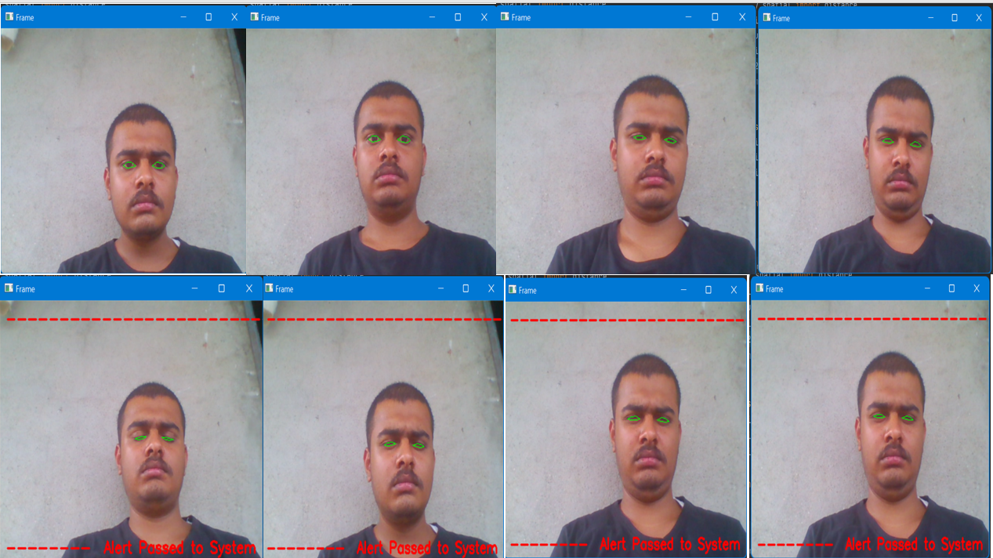

* **Drawbacks**

PERCLOS: Sometimes a driver who is trying to stay awake can fall asleep with his eyes open, this is the disadvantage of PERCLOS. Another problem with this system is that the curve for the warning is very steep at the end, which means that no warning is given at an early stage, and then the situation is very serious quickly.

LDWS: If the driver is drowsy, sooner or later the vehicle will drift to the side of the road and when it crosses the lane boundaries a warning signal is given to alert the driver. The problem with this system is that the warning signal is given every time the driver crosses the line, it does not take into consideration that the crossing could be intentional.

SVM: This framework is resulting in the accuracy of 100%, but its result is achievable in the lower frame rate, which leads us to the missed facial expression.

HMM: Drawback because older people have a deeper wrinkle. Also, HMM technique is implemented for the tracking of an eye based on color and its geometrical features, but the system fails to detect the face its driver is not looking forward and designed for the indoor conditions

Eye Detection Systems: The eye detection systems are good but not perfect, when the driver is wearing glasses there might be errors in the detection, which in some systems lead to false warnings. Sunglasses cause problems that almost none of the systems can deal with, which makes inattention detection almost impossible when the driver is wearing sunglasses. Different ethnical people are another problem, the eyes of Asian people differ from European people, but most manufacturers claim that it should not be a problem.

* **Conclusion**

The main idea of this systematic review is to discover state-of-the-art research in the drowsiness detection system. The systematic review provides details of behavioral, vehicular, and physiological parameters-based drowsiness detection techniques. These techniques are elaborated on in detail and their pros and cons are also discussed. The comparative analysis showed that none of these techniques provide full accuracy, but physiological parameters-based techniques give more accurate results than others. Their non-intrusiveness can be reduced using wireless sensors on the driver’s body, driving seat, seat cover, steering wheel, etc. A hybrid of these techniques such as physiological measures combined with vehicular or behavioral measures helps in overcoming the problem associated with individual techniques thus resulting in improved drowsiness detection results like the combination of ECG and EEG features achieve the high-performance results emphasizing the fact that combining the physiological signals improves the performance instead of using them alone. SVM is the most commonly used classifier which gives better accuracy and speed in most situations but is not suitable for large datasets. HMM shows a less error rate, but both CNN and HMM are slow in training and expensive as compared to the SVM classifier.

* **Future Work**

Future works may focus on the utilization of outer factors such as vehicle states, sleeping hours, weather conditions, mechanical data, etc, for fatigue measurement. Driver drowsiness poses a major threat to highway safety, and the problem is particularly severe for commercial motor vehicle operators. Twenty-four-hour operations, high annual mileage, exposure to challenging environmental conditions, and demanding work schedules all contribute to this serious safety issue. Monitoring the driver’s state of drowsiness and vigilance and providing feedback on their condition so that they can take appropriate action is one crucial step in a series of preventive measures necessary to address this problem. Currently, there is no adjustment in zoom or direction of the camera during operation. Future work may be to automatically zoom in on the eyes once they are localized.

* **References**

[1] International Organization of Motor Vehicle Manufacturers. (2018). Provisional Registrations or Sales of New Vehicles. [Online]. Available: <http://www.oica.net/wp-content/uploads/>

[2] Wards Intelligence. (2018). World Vehicles in Operation by Country, 2013–2017. [Online]. Available: <http://subscribers.wardsintelligence.com/data-browse-world>

[3] National Highway Traffic Safety Administration. (2018). Traffic Safety Facts 2016. [Online]. Available: <https://crashstats.nhtsa.dot.gov>

[4] Chisty et. al. <http://www.ijcstjournal.org/volume-3/issue-4/IJCST-V3I4P38.pdf>

[5] Muhammad Ramzan et. Al. <https://ieeexplore.ieee.org/document/8704263>

[6] Wanghua Deng et. al. <https://ieeexplore.ieee.org/document/8808931>

[7] Mika Sunagawa et. al. <https://ieeexplore.ieee.org/document/8933427>

[8] Morshed Chowdhury et. al. <https://ieeexplore.ieee.org/document/9524576>

[9] D. Budgen and P. Brereton, ‘‘Performing systematic literature reviews in software engineering,’’ in Proc. 28th Int. Conf. Softw. Eng., May 2006, pp. 1051–1052.

[10] reference web. <https://www.ukessays.com/essays/information-technology/motivation-for-drowsiness-detection-information-technology-essay.php#citethis>

[11] Source code: <https://github.com/AjayWalke/Driver-Drowsiness-Dtection-System-BTP---2-Year>